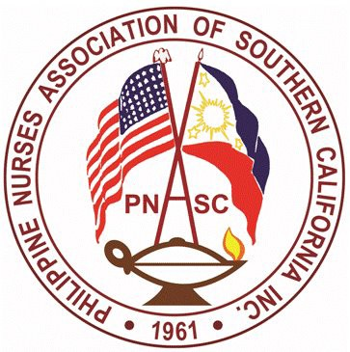

PNASC Inc.
Chapter Member of PNA America
PHILIPPINE NURSES ASSOCIATION OF SOUTHERN CALIFORNIA
Address: 899 S. Bronson Ave. Los Angeles, CA 90005
Webpage: www.mypnasc.org

PHOTO RELEASE CONSENT
I authorize the PNASC Awards Committee to publish the attached photograph. I further consent that the above can be used by the AWARDS for
- Publication
- As part of an exhibit
- As a part of a visual presentation
I waive any right to compensation for the above uses. I hold the PNASC harmless from and against any claim for injury or compensation resulting from the activities authorized by this agreement.
Furthermore, the photograph hereby submitted becomes a property of PNASC and I will not in any way claim or demand for its return.
The term “photograph” as used in this agreement, shall mean motion picture or still photography in any format, as well as videotape, video disc and any other mechanical means of recording and reproducing images.

Name: ____________________________________________________________________

Contact Number: _____________________________________________________________

Signature: _________________________________________________________________

Date: ___________________

Attach a most recent (no longer than 2 years) oﬃcial photo of the candidate. (Passport size, colored photo preferred)

This form must be submitted with the original completed nomination form.

2023 Scholarship Awards

