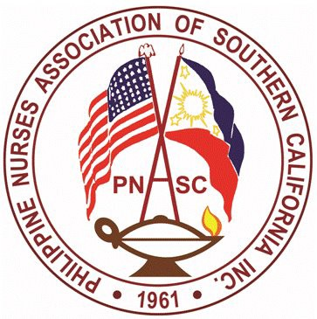

PNASC Inc.
Chapter Member of PNA America
PHILIPPINE NURSES ASSOCIATION OF SOUTHERN CALIFORNIA
Address: 899 S. Bronson Ave. Los Angeles, CA 90005
Webpage: www.mypnasc.org

Dear Esteemed PNASC Colleagues,

Greetings from your organization, the PNASC!

It is that time again to nominate a colleague to the PNASC Annual Excellence Awards. PNASC has been celebrating the outstanding achievements and significant contributions of its members to the nursing profession.

The categories are:
□ Advance Nursing Practice (MSN, NP, DNP, PhD) Scholarship Award
□ Nursing Degree (BSN) Scholarship Award

The selected awardees will be honored during our May 2023 Nursing Event. Location, Date and Time to follow.

Enclosed are the criteria for awards and nomination forms. Please complete the form and return by electronic mail on or before March 30, 2023. Late submission will not be accepted.

Please send entries and documents to:
doriannepnasc@gmail.com
cc: mariatsagunpnasc2022@gmail.com

Thank you.

Sincerely,
Dorianne Tillano- Lebrette NP-C, PMHNP- BC
Chair , Program and Awards Committee

Eligibility Requirements:

□ Applicant must be an active member of PNASC and in good standing for one full year prior to application.
□ Applicant must be currently enrolled or admitted to an accredited program (refer to: https://www.rn.ca.gov/education/rnprograms.shtml or https://www.acenursing.org/)
□ Continuing students must have a minimum of 3.0 Grade Point Average
□ Applicant must demonstrate an active commitment to and understanding of the PNASC’s, mission, vision and values.
□ Scholar (s) must submit a Progress Report at the end of the academic year to the Chair of the Scholarship Committee (email: doriannepnasc@gmail.com).
□ Must be Nominated by a paid member of PNASC

Criteria

□ Nominee must be a paid member of PNASC for at one year (1) year and in good standing. A letter of validation indicating the number of years is required from the PNASC membership chairperson. (5% pts.)
□ A biodata/ resume with a most recent 2x2 size photo (10%)
□ Must be currently enrolled in a nursing accredited program (5%).
□ Must be Nominated by a paid member of PNASC (10%)
□ Must be in good education standing (10%). Attach an unofficial transcript.
□ Must provide two (2) letters of recommendation from either: (20%)
- A current faculty/supervisor or an employer/ co- worker
- Recommendation must be other that the nominator
□ Participation in Community Activities, Leadership roles, certification, publication, research paper or Award and Achievements (10%)
□ An essay in a one- page legal size 8x11 of at least 250 words of specific ways that this scholarship will assist you in attaining your goals (30%)

Note: If chosen as an awardee, attendance is required during the May 2023 PNASC event.

NOMINATION FORM

Name of the Nominator:

Address Telephone Number: Home

Work Number: Cellphone number:

E-mail address:

PNASC position:

PNASC current member □ Yes □ No
Number of years as a member

Name of Person you feel deserves the recognition:

Do you recommend the applicant for the PNASC 2023 Scholarship Award?
Strongly recommend | Recommend | Recommend with reservations | Do not recommend

Please provide a brief specific statement as to why you wish to nominate this specific PNASC member. In what way did the individual make an outstanding impact or demonstrate the value and guiding principles of the PNASC?

Submit the completed application form with attachments identified in the checklist on or before March 31, 2023.
Email completed forms to:
Email to: doriannepnasc@gmail.com
CC: mariatsagunpnasc2022@gmail.com

