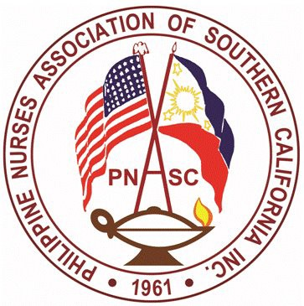

PNASC Inc.
Chapter Member of PNA America
PHILIPPINE NURSES ASSOCIATION OF SOUTHERN CALIFORNIA
Address: 899 S. Bronson Ave. Los Angeles, CA 90005
Webpage: www.mypnasc.org

LETTER OF RECOMMENDATION

TO THE RECOMMENDER: This applicant is applying for the Philippine Nurses Association of Southern California (PNASC) 2023 Scholarship Award and has requested that your evaluation be included as part of the information on which the selection committee will base its decision. We encourage your candidness in providing an honest and thorough evaluation of the applicant. Recommendation letters received by PNASC are the property of the organization.

Name of Applicant:

Recommender Information:

Recommender Name:

Title:

Organization:

Telephone:

Email Address:

Address:

1. How long have you known the applicant and in what capacity?

2. Personal and professional appraisal (please check the appropriate box for each category).

 | Very Strong | Strong | Average | Below | N/A
Intellectual Capability
Leadership Potential
Ability to work well with people
Initiative/ Self- discipline
Interpersonal skills

3. Please note any strengths and/ or weakness as well as academic and/ or professional achievements of the applicant and his/ her potential for succeeding in the academic and as a healthcare professional.

4. Do you recommend the applicant for the PNASC 2023 Scholarship Award?
Strongly recommend | Recommend | Recommend with reservations | Do not recommend

Signature:

Date: _______________________________________

Email completed forms on or before March 30, 2023 to:
Email to: doriannepnasc@gmail.com
CC: mariatsagunpnasc2022@gmail.com

