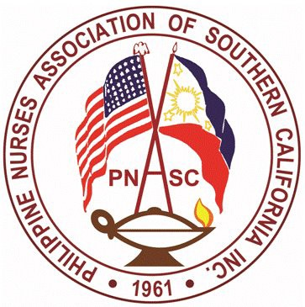

PNASC Inc.
Chapter Member of PNA America
PHILIPPINE NURSES ASSOCIATION OF SOUTHERN CALIFORNIA
Address: 899 S. Bronson Ave. Los Angeles, CA 90005
Webpage: www.mypnasc.org

APPLICATION FORM FOR NURSING SCHOLARSHIP 2023

Name of Applicant:

Address Telephone Number: Home

Work Number: Cellphone number:

E-mail address:

Position/Occupation:

Employer:

Business Address:

Name of Education Institution:

Address of Education Institution:

Institution’s Contact Person:

PNASC current member □ Yes □ No Number of years as a member

Have you applied for a PNASC scholarship before?
□ Yes, date: _________
□ No

1. Type of award the nominee should be considered. Check one.
□ Advance Nursing Practice (MSN, NP, DNP, PhD)
□ Nursing Degree (BSN)

2. Eligibility Requirements:
□ Applicant must be an active member of PNASC and in good standing for one full year prior to application.
□ Applicant must be currently enrolled or admitted to an accredited program (refer to: https://www.rn.ca.gov/education/rnprograms.shtml or https://www.acenursing.org/)
□ Continuing students must have a minimum of 3.0 Grade Point Average
□ Applicant must demonstrate an active commitment to and understanding of the PNASC’s, mission, vision and values.
□ Scholar (s) must submit a Progress Report at the end of the academic year to the Chair of the Scholarship Committee (email: doriannepnasc@gmail.com).
□ Must be Nominated by a paid member of PNASC

3. Criteria
□ Nominee must be a paid member of PNASC for at least one (1) year and in good standing. A letter of validation indicating the number of years is required from the PNASC membership chairperson. (5% pts.)
□ A biodata/ resume with a most recent 2x2 size photo (10%)
□ Must be currently enrolled in a nursing accredited program (5%).
□ Must be Nominated by a paid member of PNASC (10%)
□ Must be in good education standing (10%). Attach an unofficial transcript.
□ Must provide two (2) letters of recommendation from either: (20%)
- A current faculty/supervisor or an employer/ co- worker
- Recommendation must be other that the nomination
□ Participation in Community Activities, Leadership roles, certification, publication, research paper or Award and Achievements (10%)
□ An essay in a one- page legal size 8x11 of at least 250 words of specific ways that this scholarship will assist you in attaining your goals (30%)
Note: If chosen as an awardee, attendance is required during the May 2023 PNASC event.

4. Attestation:
I attest to all facts contained in this form and give permission for said facts to be verified and/or used for publication.
Name of Applicant:
Date:

Applicants must submit the completed application form with attachments identified in the checklist on or before March 31, 2023.
Email completed forms to:
Email to: doriannepnasc@gmail.com
CC: mariatsagunpnasc2022@gmail.com

